|  |  |  |  |  |
| --- | --- | --- | --- | --- |
|  | Nature Coast Unitarian Universalist (NCUU) News | | | |
| 7633 N. Florida Ave. (Hwy 41)  Citrus Springs, FL 34434  352-465-4225 | |  | Nature Coast Unitarian Universalists | |
| **Website:** [**https://www.ncuu.org**](https://www.ncuu.org) | | |
| **April 2023**   |  | | --- | | **PRESIDENT’S MESSAGE** |   ***NCUU: A Welcoming Oasis***  Thanks to our energetic and innovative grounds team. Our gardens are becoming more beautiful by the day. The spirit and loving unity of our congregation continues to evolve as new members join us, new perspectives are shared with us by talented speakers, and new initiatives are launched. NCUU continues to be an oasis that welcomes diversity, justice, and spiritual growth within a cultural and political landscape that appears increasingly hostile to the social justice values that underpin Unitarian Universalism. It is imperative that we remain woke to our Seven Principles and mindfully nurture those principles on a continual basis. We should make our voices heard via whatever peaceful opportunities are afforded to us.  In his little book ***Being Peace***, the late Zen master, Thich Nhat Hanh reminds us, in the context of mindfulness training, that “*Aware of the suffering created by fanaticism and intolerance, we are determined not to be idolatrous about or bound to any doctrine, theory, or ideology. . . . We will respect the right of others to be different and to choose what to believe or how to decide. We will, however, help others renounce fanaticism and narrowness through compassionate dialogue*.” Our NCUU oasis must continue to provide a haven for reason, diversity and compassion and we must continue to advocate for our principles.  I look forward to seeing as many of you as possible at our annual meeting on April 16.  Namaste  Don Wright | | | | |
| **SUNDAY SERVICE** | | | |

**Sunday, Apr. 2, 2023**

**Speaker** – Bob Benner

|  |
| --- |
| https://ncuu.org/wp-content/uploads/2020/02/Bob-Benner-resized.jpgBob has had a varied life filled with an endless need to learn about and try new things: He’s mostly known as an educator, farmer and entrepreneur. He and Jean live on a farm on Long Island where they wrestle with retirement. Recently after a long list of life interests, Bob has come to invest time working on one 1922 Model T Touring and a 1924 Model TT truck.  Bob and Jean have been attending this fellowship since they bought a home in Hernando in 2008. In other talks to the congregation Bob has tried to elicit conversations with attendees that will, hopefully, give us more insight into each of us. This talk is no exception. |

**Topic: “**Divine Intervention**”**

Have you ever had something happen to you that was beyond serendipity? I have and will be sharing two stories of Divine Intervention in Jean and my lives. I hope you bring your own stories of Divine Interventions to the service to share as well.

**Sunday, Apr. 9, 2023**

**Speaker –** Rev. Bruce Seaman

|  |
| --- |
| C:\Users\diamo\AppData\Local\Microsoft\Windows\INetCache\Content.Word\SeamanB.JPGRev. Bruce Seaman is a retired Presbyterian Church, USA minister. He has been married for over 40 years to Nancy, Benefits Coordinator for the 7000 employees of the Marion County School Board. They have two adult children: Ray (36) who is a longtime political activist now in his own business building websites and producing digital services while also doing land sales and developing his real estate interests, and Rachel (30) who is a science education designer for online programs for the University of Florida which is top-rated in the nation. Bruce published a book on local Civil War history about a daring raid by Black combatants in Marion County entitled, “To Succeed Where Others Failed: The Untold Story of the Marshall Plantation Raid.” He made a presentation about the raid to NCUU about a year ago. |

**Topic**: “God Answers the Empire”

Easter and the resurrection event are typically understood in the church as the self-sacrifice of Jesus for the forgiveness of our sins which brings us the promise of eternal life. The problem is that Jesus' teachings about the Kingdom of God indicate no such mission, neither a universal forgiveness of sins nor eternal life after death. Recognizing the story of Easter morning in Luke 24: 1-12, we join the disciples in asking what this empty tomb means. Reflecting on Jesus' teachings, we can understand it as God's answer to the Empire and the Powers-that-be in the world of every age.

**Sunday, Apr. 16, 2023**

Annual Meeting

**Sunday, Apr. 23, 2023**

**Speaker** – Dr. Lowell Smith

|  |  |
| --- | --- |
| |  | | --- | | Lowell was born in Huntington, WV and spent his early life in Anderson, IN. He earned an AB degree at Anderson University and his MD at Indiana University. He spent 8 years as a GP in a small town in southern Michigan, including 2 years in the Air Force delivering Air Force babies. He spent three years at WV University, attaining certification in Internal Medicine and doing a fellowship in Oncology, becoming the first oncologist in Muskegon, MI. While there he established an affiliation with ECOG investigational group in cooperation with Chicago Presbyterian St Lukes. After 44 years in medicine, he retired in 2007. He also, developed an avocation in music which has greatly added to his quality of life. He is grateful for finding a church which matches his own beliefs regarding our place in this world and offers realistic views of the mysteries of our existence. | |
|  |

**Topic**: “Medical Ethics & Healthcare for All”

It is a puzzle that most people believe that medical care should be available to all persons, but a method for providing that care cannot be agreed to by the citizenry of our country. Why are there such blocks to achieve this goal and what systems have been proposed to offer such care? Are there any ways we can influence adoption of affordable medical care for all?

|  |
| --- |
|  |

**Sunday, Apr. 30, 2023**

**Speaker** – UU Rev Carole Yorke

|  |
| --- |
| **C:\Users\diamo\AppData\Local\Microsoft\Windows\INetCache\Content.Word\YorkeC.JPG**Rev. Carole has been visiting us at NCUU since about 2000, and is delighted that we continue to invite her to guest preach. Now retired in Port St. Lucie with her NOW FOUR Pomeranians, she has served three churches in Florida. She was ordained in Plainfield NJ over 25 years ago, and continues to preach occasionally, do Memorial services and lead Bereavement Groups at the UU Fellowship of Vero Beach. |

|  |
| --- |
|  |

**Topic**: “Oh My god what Have They Done with Our Principles?”

General Assembly this year is taking up a proposal that will change the wording of our Principles. This process is not new in our history, but we need to talk. A vote of 50% is needed this year. Then after a year of conversation and study, a vote of 60% is necessary for adoption. Every congregation has a say and a vote. I hope to answer the question “what’s going on?”

**NCUU Board of Directors**

|  |  |
| --- | --- |
| President | Don Wright |
| Vice-President | Connie Hart |
| Clerk | Margo Wilson |
| Directors | Rob Deremer, Carole Goodman, John Ivens, Shirley Leonard, Lowell Smith, and Mike Taylor |

## ****NCUU Committees****

|  |  |
| --- | --- |
| Building | Lowell Smith |
| Bylaws | Open |
| Caring Committee | Jeanne Wright |
| Denominational Affairs | Bree Hill |
| Finance | Shirley Leonard |
| Grounds | Chas Anderson |
| Long-Range Planning | Open |
| Media and Technology | Gordon Hart |
| Membership | Holly Alexander |
| Religious Education | John Ivens |
| Social Activities | Open |
| Social Justice | Art Jones |
| Sunday Service | Pam Ricker |

**Board of Directors**

Our board meeting is Monday, Apr. 10 (Second Monday of the month) at 10:30 a.m. If you want to place an item on the board agenda, please send it to the clerk, Margo Wilson, ([clerkatncuu@gmail.com](mailto:mclerkatncuu@gmail.com)), about a week in advance.

|  |  |
| --- | --- |
| **Announcements and News** | |
| **NCUU Pledges**    [NCUU Pledges and Youtube Video](https://youtu.be/aEXeqh_zLIQ)  Our Fellowship is still functioning and has ongoing expenses. Click the above link if you are viewing this on your email to watch the video. We are open. Please find it in your generous hearts to keep your pledges and gifts up to date. Many thanks to all of you. Checks should be sent to:  Nature Coast Unitarian Universalist Fellowship P.O. Box 94 Holder, FL 34445  Connie Hart   |  | | --- | |  |   **Financial Committee Opening**  The finance committee currently has one vacancy. Open to anyone interested in learning and helping with the church budget and financial planning. If interested, contact Shirley Leonard at [reportersr@hotmail.com](mailto:reportersr@hotmail.com) or (781) 264-5098.    **Holocaust Remembrance Day**  Beth Shalom invites us to Holocaust Remembrance Day in memory of those who perished and the few who survived.  Sunday April 16, 2PM, Kellner Auditorium behind the synagogue part of the building.  92 Civic Circle, Beverly Hills, Limited seating.    **NCUU Calendar**  Please send additions, deletions, updates, and edits to Gordon Hart, [gchshutterbug@gmail.com](mailto:gchshutterbug@gmail.com), so that he may keep the calendar updated on our website, ncuu.org.    **Newsletter Deadline**  Please Remember That the Deadline For The Next Newsletter Is Apr. 23, 2022. Late items will be included in the next newsletter.  All request entries should be sent to the email address: [ncuu.news@gmail.com](mailto:ncuu.news@gmail.com) to keep all requests organized in one place. Please send the proofread text and photo attachments. Please keep your text to a maximum of two short paragraphs. If it is longer, we will edit to shorten the announcement.   |  | | --- | | **Announcements**  Send Sunday Morning Announcements To:  [Contactncuu@Gmail.com](mailto:Contactncuu@Gmail.com) Write “For Announcements” in the subject line. Deadline is the Friday before Sunday service. | | **April Birthdays**  If your birthday is not included, and your name is not on this list, please notify the editor:  [ahaiken@yahoo.com](mailto:ahaiken@yahoo.com).  Birthdays will be celebrated for now with a card from the Caring Committee. Please take time to text, call, or email these members this month.   |  |  | | --- | --- | | Wanda Brown | Sandy Sondheim |     **April NCUU Hike**  Come hike at Rainbow Springs State Park on Wednesday, April 12.  It should be a little warmer by then, so let’s meet at 9 am in the parking area.  There is admission to the park, but I have free passes, so if we all go in together, it won’t cost anything.  We will hike the Yellow trail which goes through woods back to the river and circles back through another section of woods.  We can check out the gardens, old zoo area, and swimming area on the other side of the headsprings.  Total distance will be about 3 miles.  Well-behaved dogs are welcome.    -Holly Alexander    **Social Committee**  Sunday, April 16, 2023, the Nature Coast Unitarian Universalist Fellowship will be celebrating its 25th Anniversary! The Social Committee will provide lunch for all attending. We will also respect our members who have passed by a special time at the Memorial Garden. Please come to enjoy memories and special times told by Jean McCauley about the history of the fellowship.    -Bonnie    **Wildhart Photography**  The photographs on the walls of the sanctuary can be purchased with 50% off the purchase price going to NCUU.  Talk to Gordon Hart if interested.  Please check out <http://www.wildhartphotography.com> for more of Gordon's photographs.  The same deal will be honored if someone from the congregation wants to order a photo from the website    **Wildlife Club**  The Wildlife Club is having their monthly meeting on the fourth Tuesday at 7pm with an exciting and interesting wildlife topic. Our next few meetings would be April 25, May23 and possibly June 27.We will definitely not have meetings in July and August but resuming in September. |

|  |
| --- |
| New Members |

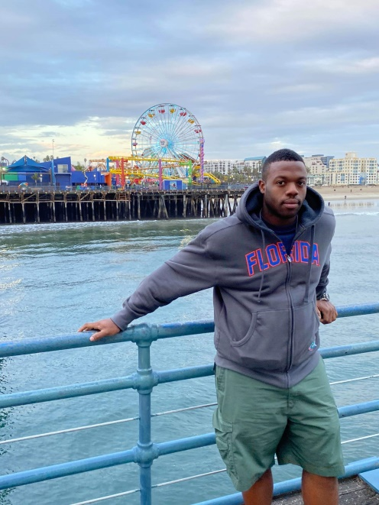

LeVaris Sims (Ted)

Hello! My name is LeVaris Sims aka (Ted). I was born and raised in Belleview Fl, and have lived in Marion country about all my life. I now live in Dunnellon and help clean up the Rainbow River and other waterways. In Marion and Citrus County I have volunteered with multiple non-profits, Rotary clubs, and churches. Giving back what I could through my time, talent, and treasure, I've helped with multiple One Rake At A Time cleanups involving Duke Energy, YMCA, and other groups to make our world a better place. I continue to work with organizations volunteering where I can.

- Service Above Self!

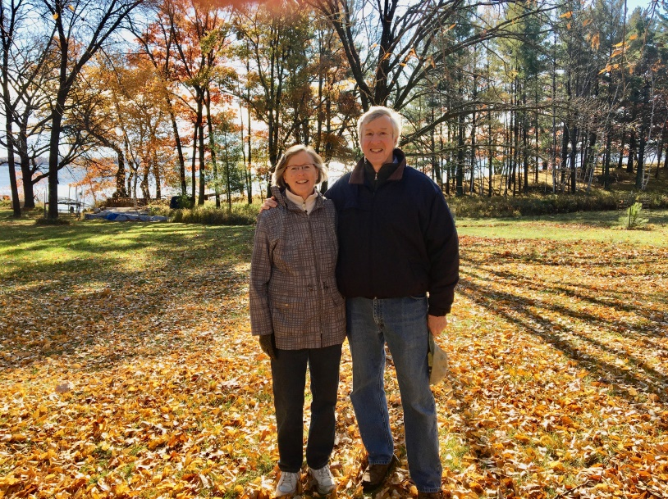

Tom and Anne Utschig

Tom and Anne moved to Inverness in March 2020 from Venice, where they were members of the Unitarian church there.  They have enjoyed getting back to in-person services this year.  They have been active Unitarians since the 1970s and are members of the UU Congregation in Eau Claire, WI, where they spend the summer months.  Tom is a retired United States Bankruptcy Judge, and Anne is a retired professor of English linguistics.  They enjoy biking, and traveling and exploring in their motorhome.